**Project**

**Hosting a PHP server on website and saving the data in a RDS and monitoring the health of instance using Route 53**

**I)Database creation**

1.Create a MYSQL DB

2.create a New SG and allow MYSQL/AURORA at 3306 port

3. select the same SG while creating MYSQL DB

4.database is created

**II)Launch an EC2 instance**

1.create a pem key

2.Allow SSH,HTTP,HTTPS anywhere

**III)CONVERT A PRIVATE KEY TO PPK**

1.In **putty gen** load the pem file

2.save private key and name it with .ppk extension

**IV)Install Apache web server with PHP**

**1.Type following commands in your instance**

* sudo yum update -y
* sudo amazon-linux-extras install php8.0 mariadb10.5 (this command works only in amazon Linux 2)
* sudo yum install php -y (the above command worked in amazon linux 2, we can skip this command)
* cat /etc/system-release (Just to check the version of linux)
* sudo yum install -y httpd
* sudo systemctl start httpd
* sudo chkconfig httpd on

**V)File permission for Apache webserver**

* sudo groupadd www
* sudo usermod -a -G www ec2-user
* exit(to logout to refresh new permissions)
* connect back to the instance
* groups ( just to check the groups associated with the instance)
* Give the ownership of the group /var/www using the following command:

sudo chown -R root:www /var/www

* Change the permissions of the /var/www folder using the following command:

sudo chmod 2775 /var/www

* Give permissions to the directory and files using the following command:

find /var/www -type d -exec sudo chmod 2775 {} +

find /var/www -type f -exec sudo chmod 0664 {} +

**Setting up file permissions is completed**

**VI)Connect your apache webserver to your database instance**

* Change the directory to /var/www and create a new subdirectory named inc with the following command:

**cd /var/www**

**mkdir inc**

**cd inc**

* Create a new file in the inc directory named dbinfo.inc, and then edit the file using the following command:

**vim dbinfo.inc**

in the above file give following commands

<?php

define('DB_SERVER', 'db_instance_endpoint');

define('DB_USERNAME', 'tutorial_user');

define('DB_PASSWORD', 'master password');

define('DB_DATABASE', 'sample');

?>

* Change directory to var/www/html using the following command:

**cd /var/www/html**

VII)

* Create a new file name as SamplePage.php and add the following code:

**vim SamplePage.php**

**paste the below code in SamplePage.php**

<?php include "../inc/dbinfo.inc"; ?>

<html>

<body>

<h1>Sample page</h1>

<?php

/* Connect to MySQL and select the database. */

$connection = mysqli_connect(DB_SERVER, DB_USERNAME, DB_PASSWORD);

 if (mysqli_connect_errno()) echo "Failed to connect to MySQL: " . mysqli_connect_error();

$database = mysqli_select_db($connection, DB_DATABASE);

 /* Ensure that the EMPLOYEES table exists. */ VerifyEmployeesTable($connection, DB_DATABASE);

 /* If input fields are populated, add a row to the EMPLOYEES table. */

$employee_name = htmlentities($_POST['NAME']); $employee_address = htmlentities($_POST['ADDRESS']);

if (strlen($employee_name) || strlen($employee_address)) { AddEmployee($connection, $employee_name, $employee_address);

}

?>

<!-- Input form -->

<form action="<?PHP echo $_SERVER['SCRIPT_NAME'] ?>" method="POST">

 <table border="0">

 <tr>

 <td>NAME</td>

 <td>ADDRESS</td>

 </tr>

 <tr>

 <td>

 <input type="text" name="NAME" maxlength="45" size="30" />

 </td>

<td>

 <input type="text" name="ADDRESS" maxlength="90" size="60" />

 </td>

 <td>

 <input type="submit" value="Add Data" />

 </td>

 </tr>

 </table>

</form>

<!-- Display table data. -->

<table border="1" cellpadding="2" cellspacing="2">

 <tr>

 <td>ID</td>

 <td>NAME</td>

 <td>ADDRESS</td>

 </tr>

<?php

$result = mysqli_query($connection, "SELECT * FROM EMPLOYEES");

while($query_data = mysqli_fetch_row($result)) {

 echo "<tr>";

 echo "<td>",$query_data[0], "</td>",

 "<td>",$query_data[1], "</td>",

 "<td>",$query_data[2], "</td>";

 echo "</tr>";

}

?>

</table>

<!-- Clean up. -->

<?php

 mysqli_free_result($result);

 mysqli_close($connection);

?>

</body>

</html>

<?php

/* Add an employee to the table. */

function AddEmployee($connection, $name, $address) {

 $n = mysqli_real_escape_string($connection, $name);

 $a = mysqli_real_escape_string($connection, $address);

$query = "INSERT INTO EMPLOYEES (NAME, ADDRESS) VALUES ('$n', '$a');";

 if(!mysqli_query($connection, $query)) echo("<p>Error adding employee

data.</p>");

}

/* Check whether the table exists and, if not, create it. */

function VerifyEmployeesTable($connection, $dbName) {

 if(!TableExists("EMPLOYEES", $connection, $dbName))

 {

 $query = "CREATE TABLE EMPLOYEES (

 ID int(11) UNSIGNED AUTO_INCREMENT PRIMARY KEY,

 NAME VARCHAR(45),

 ADDRESS VARCHAR(90)

 )";

if(!mysqli_query($connection, $query)) echo("<p>Error creating table.</p>");

 }

}

/* Check for the existence of a table. */

function TableExists($tableName, $connection, $dbName) {

 $t = mysqli_real_escape_string($connection, $tableName);

 $d = mysqli_real_escape_string($connection, $dbName);

 $checktable = mysqli_query($connection,

 "SELECT TABLE_NAME FROM information_schema.TABLES WHERE TABLE_NAME =

'$t' AND TABLE_SCHEMA = '$d'");

 if(mysqli_num_rows($checktable) > 0) return true;

 return false;

}

?>

* After Pasting the above code, close the vim by **ESC + : + WQ!**
* Now copy the public ip of the instance and give **/SamplePage.php** at end in browser

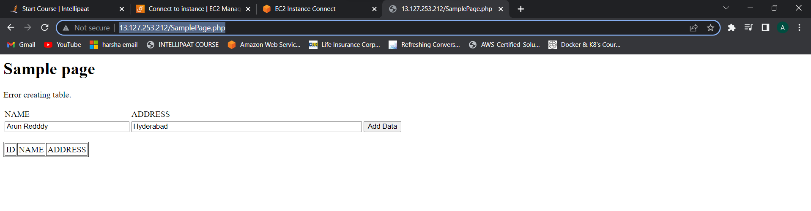

**VII)Monitor the portal using Route53**

* **Goto Route53->Health Checks->Create Health check**
* **Create A health check with following configuration**

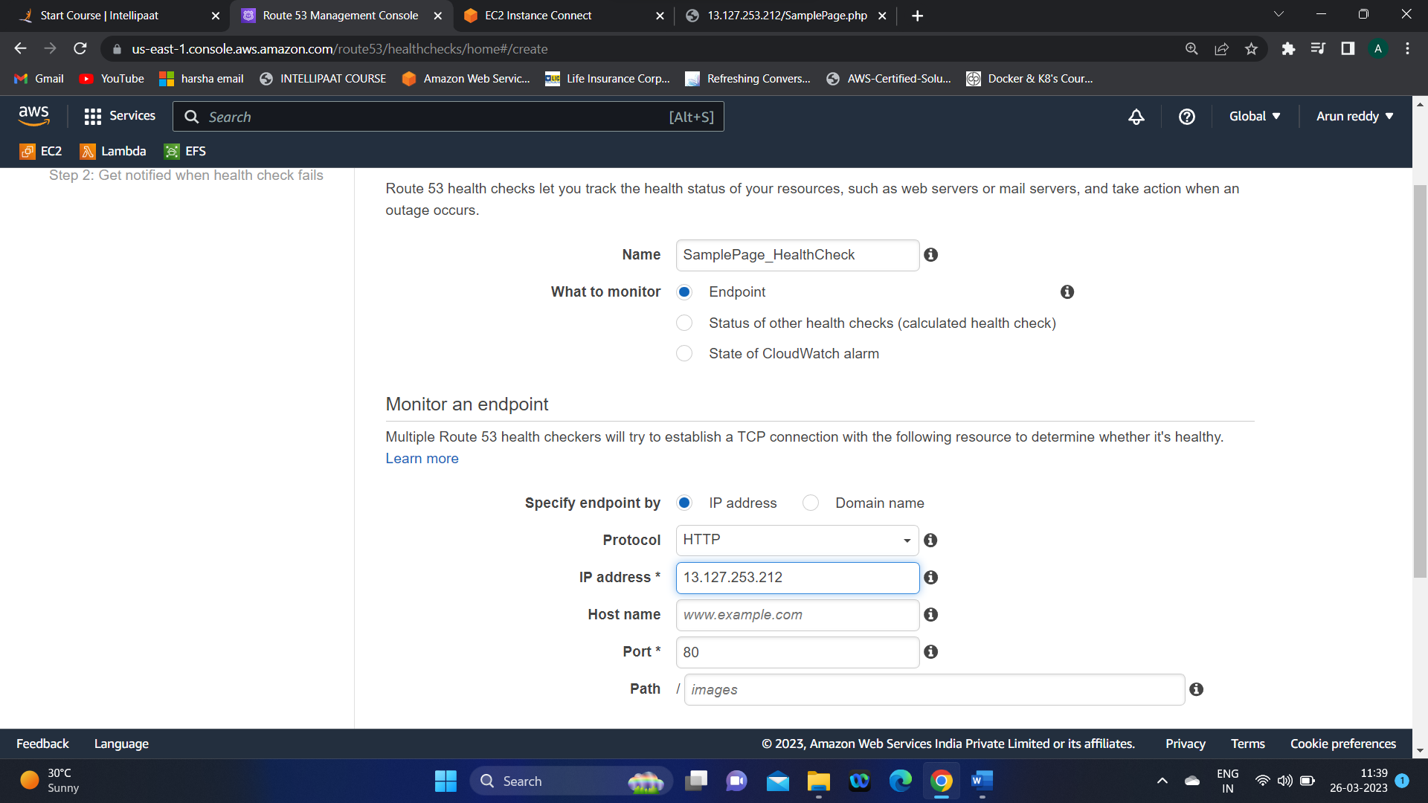

* It gives the status of your website and sends notification if it is unhealthy:

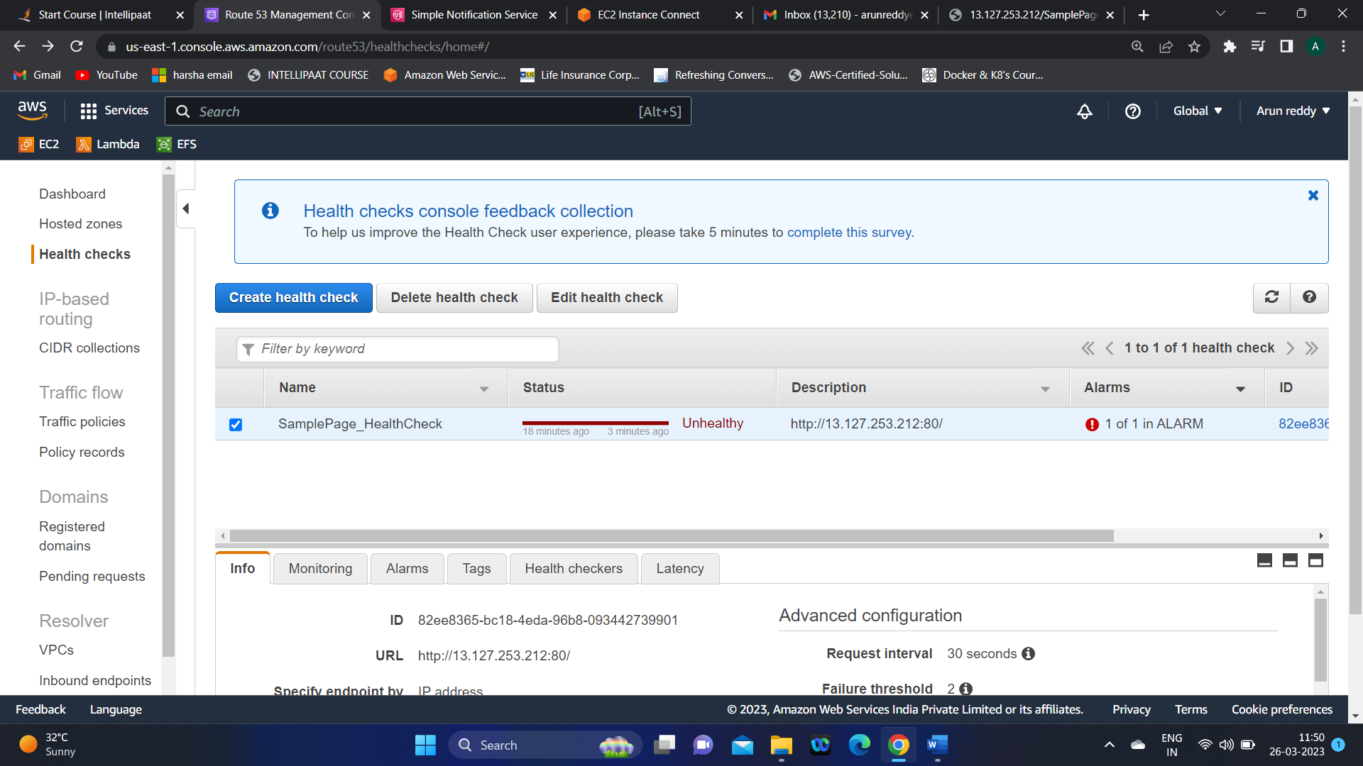

**This completes our Project……………..**